RAG-Powered SQL
Optimization Assistant
Development Documentation — Current Work, Experiments, Decisions, and Roadmap
Status: Early research and project planning • Initial engine: PostgreSQL • Initial workload: TPC-H

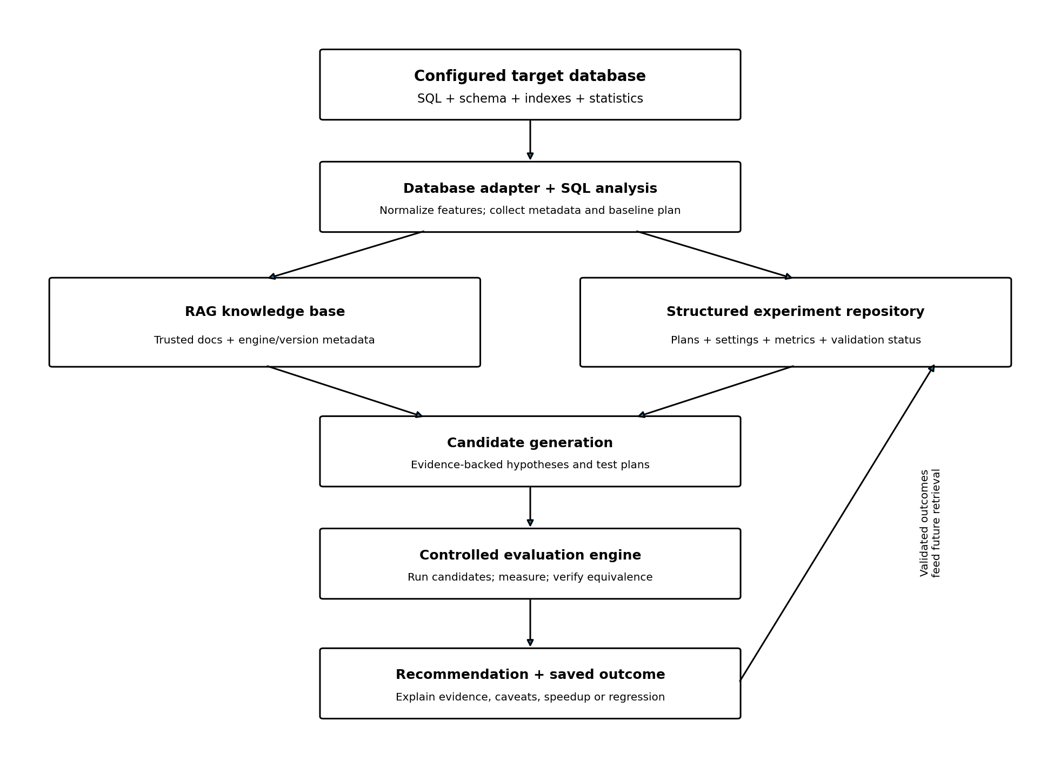
Document status: living draft. It preserves what has been discussed and recorded so far. Historical timing values are preliminary conversation records, not independently verified benchmark results.

Document guide
- 1. Executive summary and project vision
- 2. Work completed so far
- 3. Experimental environment and canonical query
- 4. Experiments and recorded results
- 5. Interpretation and limitations of current evidence
- 6. Target architecture and role of RAG
- 7. Making the optimizer general rather than TPC-H-specific
- 8. Experiment-data strategy and proposed record schema
- 9. Benchmarking methodology and safety guardrails
- 10. Implementation roadmap
- 11. Concepts to refresh before and during implementation
- 12. Problems, risks, and open questions
- 13. Immediate next actions
- 14. Documentation and experiment templates
- 15. Glossary

1. Executive summary and project vision
The project aims to build a RAG-powered SQL optimization assistant that can use trusted database documentation and historical experimental evidence to propose optimization hypotheses, test them in a controlled environment, and recommend changes only when measurements support them.
The assistant is not intended to replace the database engine's query optimizer or to let an LLM invent a final physical execution plan. The database remains responsible for producing valid plans. The assistant helps analyze plans, retrieve relevant knowledge, select candidate experiments, measure outcomes, and explain the evidence.

Core objectives
- Generalize beyond the TPC-H dataset and its specific table contents.
- Use schema-independent query features and live metadata to find relevant optimization patterns.
- Separate reusable principles from engine- and version-specific behavior.
- Measure baseline and candidate performance with repeated runs and reliable validation.
- Store experiment outcomes so future queries can benefit from validated evidence.
- Start with PostgreSQL, then evaluate a second engine after the initial workflow is reliable.

Guiding principle
TPC-H is the initial experimental workload, not the product boundary. The intended system should learn from diverse evidence and evaluate whether a retrieved pattern applies to the current database. A similar historical result is a hypothesis source, not proof that the same change will help a new workload.

2. Work completed so far

2.1 Initial PostgreSQL experiments
- Used a PostgreSQL database running in Docker in a container named tpch-postgres, with database tpch and user postgres.
- Used TPC-H-generated data and ran SQL through psql via docker exec.
- Tested approximately seven to eight plan/configuration combinations for a customer-orders aggregation query.
- Explored PostgreSQL planner settings involving enable_hashjoin, enable_mergejoin, enable_nestloop, and jit.
- Observed that JIT-off and index-related scenarios were faster than the recorded default run in the historical measurements.
- Noted that turning off a join method can lead to a much slower plan in the tested workload.
- Began shaping the project idea: use RAG and prior experiments to inform optimization hypotheses, while preserving database-native planning and measured evaluation.

2.2 Planning completed
- Drafted a project plan covering architecture, technology choices, MVP scope, safety rules, and implementation phases.
- Identified a likely initial stack: Java + Spring Boot, Spring AI, PostgreSQL + pgvector, JDBC adapters, SQL parsing, and React (with API/CLI acceptable first).
- Identified the need to preserve full EXPLAIN output, engine/version metadata, schema/index context, settings, repeated timings, and validation status.
- Agreed that documentation will evolve alongside implementation rather than being treated as a final one-time task.
- Identified a need to expand experiments across different query shapes, schemas, data distributions, and eventually database engines.
Not yet completed: a reproducible benchmark collector, a validated experiment database, the RAG ingestion/retrieval implementation, automated candidate evaluation, and multi-engine support.

3. Experimental environment and canonical query
Item | Recorded context
Database engine | PostgreSQL (version not yet recorded in the experiment log)
Container | tpch-postgres
Database / user | tpch / postgres
Dataset | TPC-H-generated data; scale factor not yet recorded in the retained log
Execution method | psql through docker exec
Plan capture | EXPLAIN ANALYZE; later experiments also used EXPLAIN (ANALYZE, BUFFERS)
Experiment count | Roughly 7–8 combinations, based on the log

Canonical query
SELECT c.c_name, SUM(o.o_totalprice)
FROM customer c
JOIN orders o ON o.o_custkey = c.c_custkey
WHERE c.c_mktsegment = 'BUILDING'
GROUP BY c.c_name;
The query joins customer to orders by customer key, filters customers to the BUILDING market segment, and aggregates order total price by customer name. The quoted string literal is required; an earlier attempt without quotes around BUILDING was noted as invalid SQL.

4. Experiments and recorded results
The values below are copied from the retained experiment log. They were recorded from the conversation, not reconstructed from complete terminal output. They should be treated as historical observations until the exact commands, plans, index definitions, settings, and timings are revalidated.
# | Scenario | Planning time | Execution time | Recorded notes
1 | Default plan, JIT ON | 3.231 ms | 479.241 ms | Reported baseline
2 | JIT OFF | 0.594 ms | 382.716 ms | Faster than recorded baseline in this run
3 | Hash join forced | 0.927 ms | 371.364 ms | Fastest of the listed join-method-only runs
4 | Merge join forced | 0.592 ms | 525.618 ms | Slower than recorded baseline in this run
5 | Nested loop forced | 0.844 ms | 744.049 ms | Slowest listed run
6 | Index experiment A | 1.554 ms | 252.539 ms | Index pairing/complete plan needs verification
7 | Index experiment B | 0.695 ms | 261.856 ms | Composite index among tested; exact mapping uncertain
8 | Best observed run | 6.811 ms | 239.337 ms | Index-related; bitmap index scan reported/visible; repeat and inspect full plan

4.1 Indexes discussed
- idx_customer_mktsegment — an index on customer market segment.
- A composite index on (c_mktsegment, c_custkey).
- idx_orders_custkey — an index on orders customer key.
The retained notes do not conclusively map every index combination to every timing. Current indexes should be inspected (for example, through pg_indexes), and each scenario should be rerun with its exact DDL and plan.

4.2 Relative differences (descriptive only)
Using the recorded values only, the 239.337 ms run is approximately 50.1% lower in execution time than the 479.241 ms baseline. This is a descriptive comparison between recorded runs, not a validated speedup claim: the index/configuration mapping is uncertain, repeated-run statistics are absent, and cache/order effects have not been controlled.
The JIT-off run (382.716 ms) was approximately 20.1% lower than the recorded baseline. The forced hash join (371.364 ms) was approximately 22.5% lower, while merge join (525.618 ms) and nested loop (744.049 ms) were slower than that baseline. These comparisons apply only to the recorded runs of this query and environment.

5. Interpretation and limitations of current evidence
- The results demonstrate that planner settings and indexes can materially change execution time for this workload.
- The results do not prove that a forced hash join, JIT-off configuration, or a particular index is generally superior.
- A single query over one generated dataset cannot establish generalization across schemas, workloads, or database engines.
- Planning time is distinct from execution time; a candidate should be judged using a stated objective and workload context.
- A fastest single run may be caused by cache state, background load, run order, or measurement noise.
- The historical index-to-timing mapping is partly uncertain, and the full original terminal output is not retained in the experiment log.
- The historical log includes a prior note about approximately 63.283 ms of JIT overhead, but its exact context needs to be rechecked in the full plan output.

Evidence status labels
Label | Meaning
Historical / unverified | Copied from earlier notes; exact conditions or pairing not yet reproduced.
Reproduced | Same query and recorded configuration have been rerun successfully.
Validated | Reproducible measurement, full context, and output-equivalence checks are recorded.
Generalized hypothesis | Observed in multiple contexts but not a universal rule; conditions and limitations documented.

6. Target architecture and role of RAG

6.1 Main components
Component | Responsibility | Initial direction
Frontend | Submit SQL and inspect plans, metrics, and recommendations. | React; can be deferred
API/orchestration | Manage jobs, candidate evaluation, cancellation, and reports. | Java + Spring Boot
SQL analysis | Extract query structure and create normalized features/fingerprint. | JSqlParser or dialect-aware parser; validate dialect support
Database adapter | Collect metadata, run EXPLAIN, execute permitted tests, manage session settings. | JDBC + engine-specific adapters
RAG retrieval | Retrieve trusted docs and similar experiment summaries. | Spring AI + pgvector initially
Experiment repository | Store runs, plans, settings, timings, buffers, and validation. | PostgreSQL relational tables
Candidate generation | Propose a small set of evidence-backed hypotheses. | LLM constrained by evidence and adapter capabilities
Evaluation engine | Run candidates, repeat measurements, compare outcomes, validate equivalence. | Controlled test environment
Reporting | Explain measured differences, evidence, caveats, and approval requirements. | API response first; React later

6.2 Keep the database optimizer in control
The assistant should not directly fabricate a final physical plan and force the database to execute it. It should propose supported changes or permitted session-level experiments, ask the target engine to produce a valid plan, then measure and validate the result. Persistent changes such as index creation should require explicit approval and should first be evaluated in an isolated environment.

6.3 Experiment feedback loop
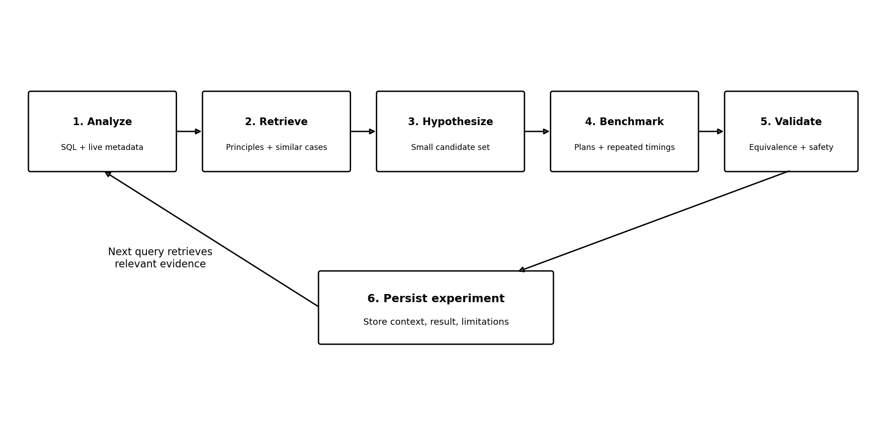

7. Making the optimizer general rather than TPC-H-specific
The intended product is database-agnostic at the architecture level, but behavior will remain engine-aware. The first implementation should be PostgreSQL-specific enough to work reliably, with engine-specific behavior behind adapter interfaces. MySQL or another engine can be added after the core workflow and validation are stable.

7.1 Three distinct knowledge/context stores
Category | What belongs here | How it is used
General optimization knowledge | Join algorithms, indexing principles, selectivity, statistics, aggregation, sorting, cardinality estimation. | Retrieved as explanatory principles; tag engine/version applicability.
Historical experiment evidence | Query features, context, exact candidate changes, plans, timings, repeated-run stats, validation and caveats. | Find comparable cases; use as evidence, not as a guarantee.
Live database context | Current schema, types, indexes, constraints, table sizes, statistics, engine version, current plan. | Collected at optimization time; prevents stale assumptions about the target database.

7.2 Generalization dimensions
- Query structure: filters, joins, join count, grouping, sorting, subqueries, EXISTS, LIMIT, and aggregation.
- Data characteristics: table size, selectivity, skew, cardinality, NULL frequency, and correlations.
- Physical design: no index, single-column indexes, composite indexes, column order, and statistics.
- Execution environment: engine/version, settings, memory, parallelism, cache state, and resource contention.
- Candidate type: permitted planner settings, index proposals for human review, query rewrites with equivalence validation, and statistics changes in test environments.

7.3 Candidate datasets and workloads
Workload | Purpose | Status
TPC-H | Existing analytical workload; establish repeatable baseline. | Already used; current results need revalidation.
TPC-H at multiple scale factors | Study how table size affects plan choices and runtime. | Proposed
TPC-DS | Broader analytical query shapes and schema complexity. | Proposed; not yet tested
Join Order Benchmark (JOB) | Explore join ordering and cardinality-estimation challenges. | Proposed; not yet tested
Synthetic schemas/data | Control selectivity, skew, cardinality, and index conditions. | Proposed
Unseen schema/workload | Test generalization beyond known table and column names. | Required evaluation direction

7.4 What 'learning' means in this project
Initially, learning should mean that validated experiment outcomes are persisted and can be retrieved for future cases. RAG does not automatically improve merely because more documents are embedded. Progress depends on experiment quality, feature extraction, retrieval relevance, candidate selection, and evaluation. Fine-tuning or a learned candidate-ranking model is optional future research, not an MVP requirement.

8. Experiment-data strategy and proposed record schema
Do not store only free-form text. Use structured relational records for facts and metrics, and vector search for documentation and human-readable experiment summaries. Hybrid retrieval can filter by engine/version and query/data features, then rank semantically relevant cases.
Field group | Suggested fields
Identity | experiment_id, job_id, timestamp, run_number, parent/baseline run ID
Query | SQL text, normalized fingerprint, extracted query features, parameterization notes
Environment | engine, engine_version, driver version, OS/container, dataset, scale factor
Database context | schema snapshot, table sizes, indexes, constraints, relevant statistics, settings
Candidate | candidate type, exact setting/DDL/rewrite, rationale, retrieved evidence references
Plan | EXPLAIN text/JSON, planning time, estimated rows, actual rows, node types, buffers
Measurement | execution time, repetitions, median, spread, warm-up/cache notes, timeout status
Correctness/safety | result-equivalence status, validation method, read-only status, approval status
Conclusion | measured delta, regression/improvement, limitations, reproducibility status, notes

8.1 Query features should be schema-independent
A query fingerprint can help identify repeated query structures, but retrieval should also use features such as number of joins, join predicates, predicate types, grouping/sorting, estimated selectivity, table-size ranges, index availability, and cardinality-estimation errors. Table and column names may be included as context, but should not dominate similarity if the goal is generalization.

9. Benchmarking methodology and safety guardrails

9.1 Recommended experiment procedure
- Use a dedicated local/test database or disposable clone.
- Record exact SQL, engine version, schema, indexes, statistics, relevant settings, and dataset scale.
- Capture EXPLAIN (ANALYZE, BUFFERS, SETTINGS, VERBOSE) where supported; preserve complete text or JSON output.
- Run a warm-up where appropriate, then collect multiple measured runs (the draft plan suggests 5–10) and report median plus spread.
- Record test order and cache assumptions; separate cold-cache and warm-cache tests when practical and reliable.
- Change one factor at a time during initial experiments, then use a designed matrix for interactions.
- Compare plans and metrics; don't use the fastest single execution as the sole criterion.
- Verify that candidate output is equivalent to the baseline result before declaring it valid.
- Store all results, including regressions, timeouts, failures, and inconclusive experiments.

9.2 Safety guardrails
- Use least-privilege credentials; default to read-only for metadata and SELECT analysis.
- Set statement timeouts, cancellation support, concurrency limits, and resource caps.
- Restore prior session settings after each experiment and record changes.
- Do not automatically create/drop indexes or modify global settings.
- Require explicit approval for persistent schema/configuration changes.
- Do not send sensitive schema or data to an external LLM unless policy allows it; minimize or redact context.
- Treat LLM explanations as hypotheses; keep measured facts separate from generated narrative.

10. Implementation roadmap
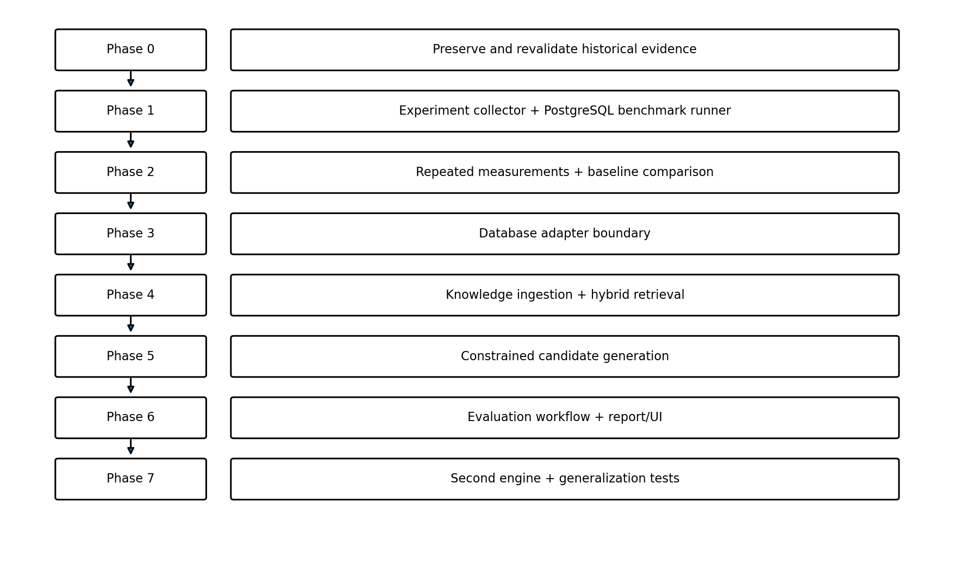
Phase | Work | Exit criterion
0 — Preserve evidence | Recover logs/screenshots if available; verify index definitions, settings, versions, and timing pairings. | Each historical experiment is reproducible or marked uncertain.
1 — Experiment collector | Create run schema and PostgreSQL benchmark runner; capture EXPLAIN and metrics. | Known query produces complete structured results.
2 — Baseline comparison | Repeat runs, calculate median/spread, compare baseline and candidates, validate outputs. | Trustworthy report for canonical TPC-H query.
3 — Adapter boundary | Define metadata, EXPLAIN, settings, execution, and capability interfaces. | PostgreSQL implementation sits behind reusable interface.
4 — Knowledge ingestion | Load trusted docs and validated experiment summaries; embed and store them. | Retrieval returns relevant, version-aware context.
5 — RAG and candidates | Generate constrained hypotheses and measurable test plans. | Suggestions contain evidence, rationale, risks, and validation steps.
6 — Evaluation/reporting | Orchestrate candidate runs and show plan diffs and metrics. | End-to-end SQL-to-report flow.
7 — Second engine | Add MySQL adapter and engine-specific documentation. | Second engine uses core workflow without mixing dialect assumptions.

11. Concepts to refresh before and during implementation
Priority | Concepts | Practical target
1 | SQL/DBMS fundamentals: joins, grouping, keys, cardinality, indexes, MVCC basics. | Explain the canonical query and its relational operations.
2 | EXPLAIN/EXPLAIN ANALYZE, join algorithms, plan nodes, costs, buffers, statistics. | Read a plan and identify testable bottleneck hypotheses.
3 | Benchmarking, medians/spread, cache effects, output equivalence, reproducibility. | Produce a trustworthy baseline-vs-candidate report.
4 | RAG, chunking, embeddings, vector search, hybrid retrieval, reranking, evaluation. | Retrieve applicable evidence and measure retrieval relevance.
5 | JDBC, Spring Boot layers, SQL parsing, adapters/Strategy pattern, job cancellation. | Build a reusable and testable experiment service.
6 | Least privilege, timeouts, test isolation, SQL validation, approval controls. | Prevent unsafe experiments and persistent unapproved changes.

Suggested 7-day refresh schedule
Day | Focus | Practice
1 | SQL and relational fundamentals | Write and explain 5–8 TPC-H queries.
2 | Indexes and plan nodes | Inspect scans, joins, and index usage in 3 plans.
3 | Planner and statistics | Compare estimated vs actual rows; inspect ANALYZE/statistics.
4 | Benchmark methodology | Repeat one baseline and one candidate; compute median/spread.
5 | RAG retrieval | Design experiment metadata and a hybrid retrieval example.
6 | Spring/JDBC/adapters | Sketch interfaces and the experiment persistence model.
7 | Safety and kickoff | Run one reproducible benchmark and save its artifacts.

This is a suggested refresh schedule, not a prerequisite to starting. Skip topics already understood and learn remaining details while implementing.

12. Problems, risks, and open questions
Issue / risk | Why it matters | Current response / next step
Uncertain index-to-timing mapping | Could lead to incorrect conclusions about which index helped. | Inspect pg_indexes and rerun exact scenarios with DDL and full plans.
Original terminal output incomplete | Historical timing values lack enough context for reproducibility. | Recover logs if available; mark unreproduced results as historical/unverified.
Only one query/workload so far | Cannot support broad generalization claims. | Add query templates, varied data distributions, schemas, and workloads.
One-run timing noise | Cache state and system load can mislead comparisons. | Warm-up, repeated runs, median/spread, record test order.
RAG may retrieve superficially similar cases | Same words/table names do not guarantee similar optimization conditions. | Use structured query/data features, engine/version filters, and hybrid retrieval.
LLM may hallucinate or overgeneralize | Could recommend invalid, unsafe, or slower changes. | Constrained hypotheses, adapter capabilities, controlled execution, validation.
Cross-engine differences | Syntax, EXPLAIN formats, settings, and optimizer behavior differ. | Adapter boundary plus engine-specific documentation and tests.
Sensitive database context | Schema or data sent to external models can create privacy risk. | Minimize/redact context; require explicit policy approval.
Scope expansion | Building all engines, UI, and advanced AI too early can delay a working MVP. | Start with PostgreSQL benchmark collection; add RAG only after evidence capture works.

Open questions to resolve during implementation
- Which PostgreSQL version and TPC-H scale factor are currently used?
- What are the exact DDL definitions and current index combinations for each historical run?
- Which query types and candidate changes belong in the first MVP?
- How will result equivalence be checked efficiently for each supported query type?
- Which performance objective matters most initially: execution latency, resource use, or a combination?
- Which additional dataset/workload should be added first after the collector is reliable?
- What is the minimum adapter contract required for a second engine?

13. Immediate next actions
- Capture PostgreSQL version, TPC-H scale factor, schema, current indexes, and relevant settings.
- Inspect index definitions for customer and orders and map them to each historical scenario.
- Rerun the canonical query with EXPLAIN (ANALYZE, BUFFERS, SETTINGS, VERBOSE), preserving full output.
- Create an experiment-run schema and a simple benchmark runner before implementing RAG.
- Repeat baseline and candidate runs with recorded warm-up/test order; report median and spread.
- Verify result equivalence for candidate configurations and mark uncertain historical records clearly.
- Define schema-independent query features and the first structured experiment record.
- Only then ingest trusted documents and validated experiment summaries into pgvector.
- Keep this document, the experiment log, and the project plan as living artifacts updated with every meaningful milestone.

14. Documentation and experiment templates

14.1 Per-experiment template
Field | Value to record
Experiment ID / date | Unique identifier and timestamp
Hypothesis | What change is expected to help, and why?
Environment | Engine/version, container, dataset, scale factor
Query | Exact SQL and normalized features/fingerprint
Baseline context | Schema, indexes, stats, settings, baseline plan
Candidate change | Exact setting, index DDL, or query rewrite
Method | Warm-up, run count, order, timeout, cache notes
Measurements | Planning time, execution times, median/spread, buffers
Correctness | Output-equivalence method and status
Outcome | Improvement/regression/inconclusive; evidence and limitations
Reproducibility | Commands, logs, plan artifact paths, status

14.2 Decision-log template
- Decision: What did we choose?
- Context: What problem or constraint led to the decision?
- Alternatives considered: What else could we do?
- Evidence: Which experiments, documentation, or measurements support it?
- Trade-offs: What becomes easier or harder?
- Status: Proposed, accepted, superseded, or rejected.

14.3 Suggested repository layout
docs/
project-plan.md
development-documentation.md
experiment-log.md
architecture-decisions/
diagrams/
experiments/
raw/
normalized/
plans/
reports/
src/
api/
sql-analysis/
experiment-runner/
database-adapters/
retrieval/
candidate-generation/
evaluation/
persistence/
This is a proposed organization. It can be adapted to the repository and implementation choices; raw outputs should remain distinguishable from normalized/derived records.

15. Glossary
Term | Meaning in this project
RAG | Retrieval-Augmented Generation: retrieve relevant external knowledge and provide it to an LLM for a grounded response.
Query plan | The database engine's chosen operations and their execution structure for a SQL statement.
EXPLAIN | PostgreSQL command that displays a query plan; EXPLAIN ANALYZE executes the query and reports actual measurements.
Cardinality estimation | Estimating how many rows an operation will produce.
Selectivity | The fraction of rows that satisfy a predicate.
Query fingerprint | A normalized representation used to identify or group structurally similar queries.
Hybrid retrieval | Combining structured filters/keyword search with vector-based semantic retrieval.
Result equivalence | Checking that baseline and candidate queries produce the same required result.
Generalization | Performing usefully on unseen schemas, workloads, data distributions, or engines rather than merely recalling familiar examples.
Adapter | An engine-specific implementation behind a shared interface for metadata, plans, settings, and execution.

Closing note
The project is currently in the exploratory and planning stage. The strongest next step is to make the current TPC-H experiments reproducible and structured. That evidence-first foundation will make it possible to evaluate whether RAG genuinely improves candidate selection and whether the approach generalizes to unfamiliar schemas and workloads.

